⚙️ Root Cause
This happens when the SQL Server WMI provider (which Configuration Manager uses to display services) is not registered correctly or is corrupted during setup.
SQL Server Configuration Manager relies on:
📁 sqlmgmprovider.dll → the WMI provider DLL file located in
C:\Program Files (x86)\Microsoft SQL Server\<version>\Shared\
If this DLL isn’t registered with Windows WMI, Configuration Manager can’t show any SQL services — hence, the “no items” message.
Fix
✅ Step 1:
So for SQL Server 2022 → folder is 160.
C:\Program Files (x86)\Microsoft SQL Server\160\Shared
Make sure below highlighted available
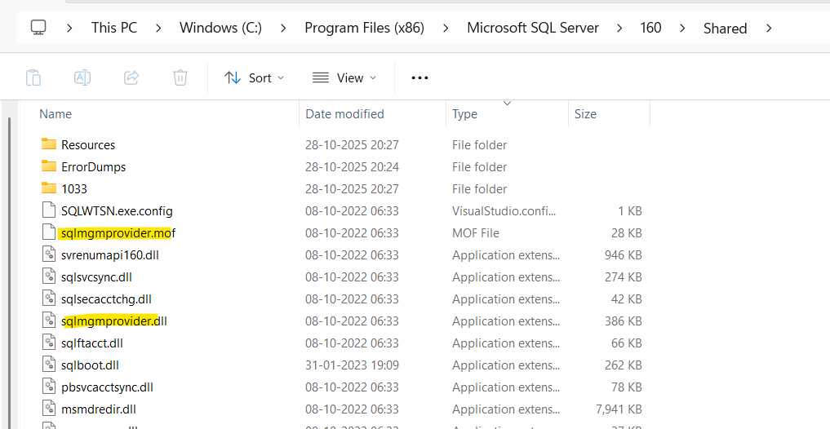
✅ Step 2: Open Command Prompt as Administrator
Then run the following command (adjust version number if needed):
cd "C:\Program Files (x86)\Microsoft SQL Server\160\Shared"
mofcomp sqlmgmprovider.mof
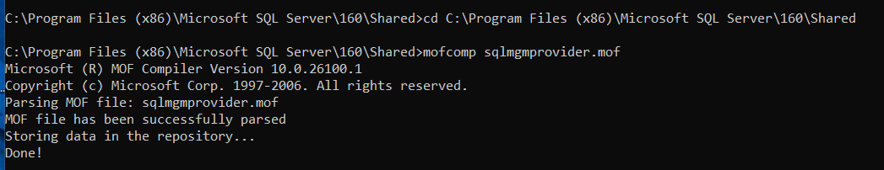This re-registers the SQL Server WMI provider.

✅ Step 3: Restart WMI Service
Run these commands:
net stop winmgmt
net start winmgmt
Then reopen:
SQL Server Configuration Manager

If both files are missing:
sqlmgmprovider.dll and sqlmgmprovider.mof
Repair or Add Shared Features
You can reinstall just the missing WMI provider component.
- Open SQL Server Installation Center
  - (setup.exe from your SQL 2022 media or installer)
- Go to:
Maintenance → Repair
- Select your SQL Server 2022 instance.
- Continue → let it complete.
🟩 Alternate:
If you only installed “Client Tools,” re-run setup →
Add features to an existing instance → check:
Shared Features → Management Tools (SQL Server Configuration Manager)
Then install.
Repeat ✅ Step 2: Open Command Prompt as Administrator
And ✅ Step 3: Restart WMI Service

